**Configure The Mobile App For Controlling Motor**

**Using Buttons**

|  |  |
| --- | --- |
| Date | 17 November 2022 |
| Team Id | PNT2022TMID46546 |
| Title | Hazardous Area Monitoring for Industrial Plant using IoT |

**App Blocks to render the values and display it in app**

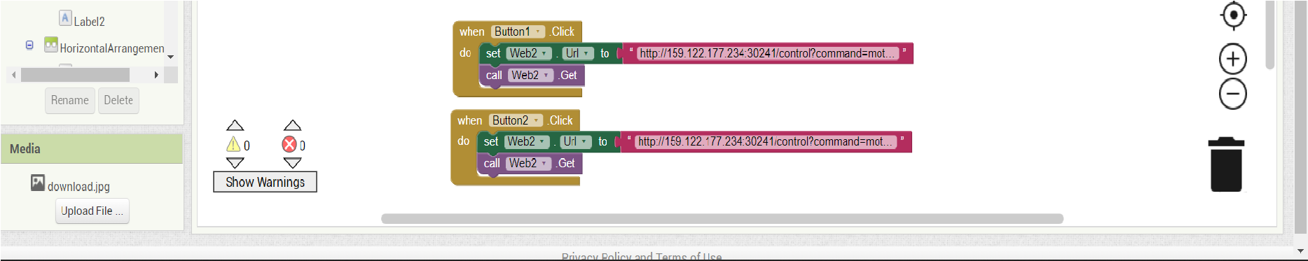

**Python block that changes the state of motor based on input from app**

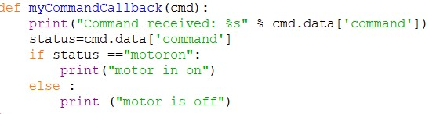

**Output window**

